Nama : Tarisa Dwi Septia

NIM : 205410126

**Topologi Praktik Ke-4**

1. 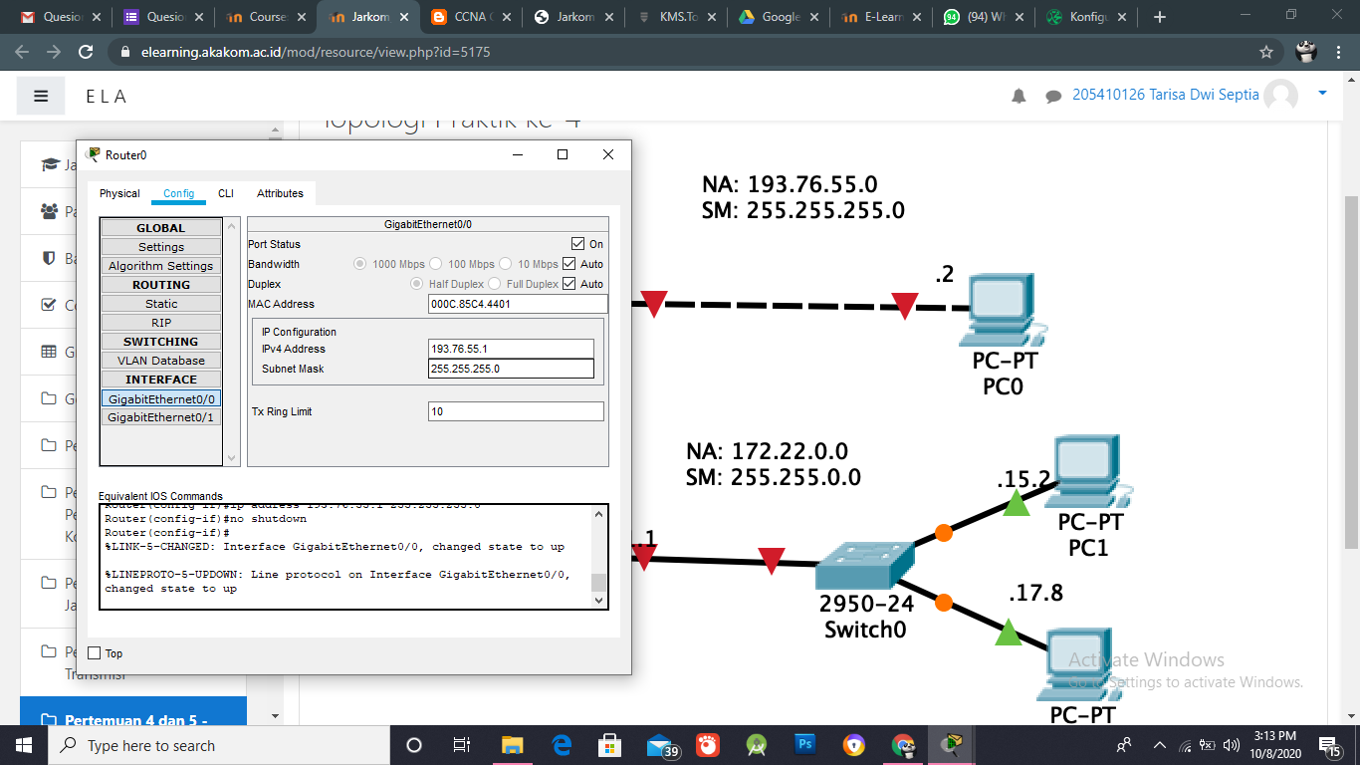Setting IP Router0
2. 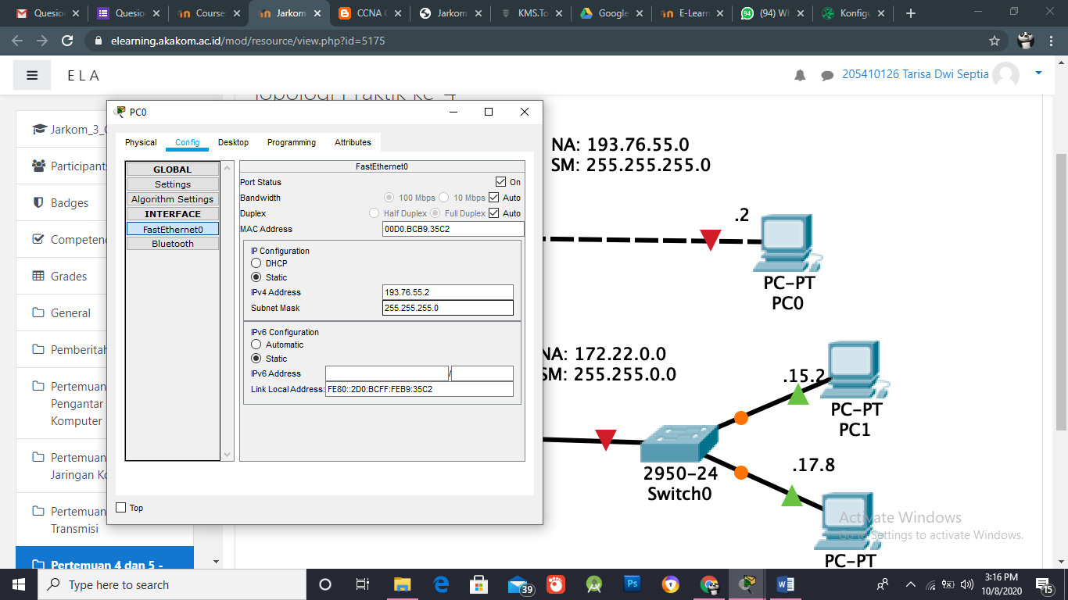Seting IP PC0
3. 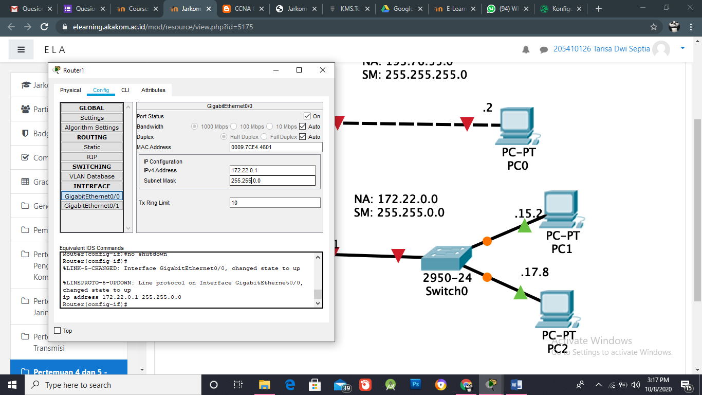Setting IP Router1
4. 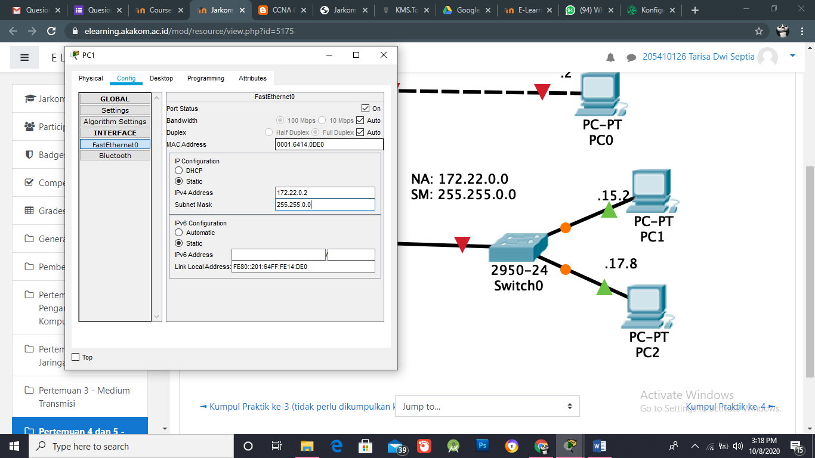Setting IP PC1

1. Setting IP PC2

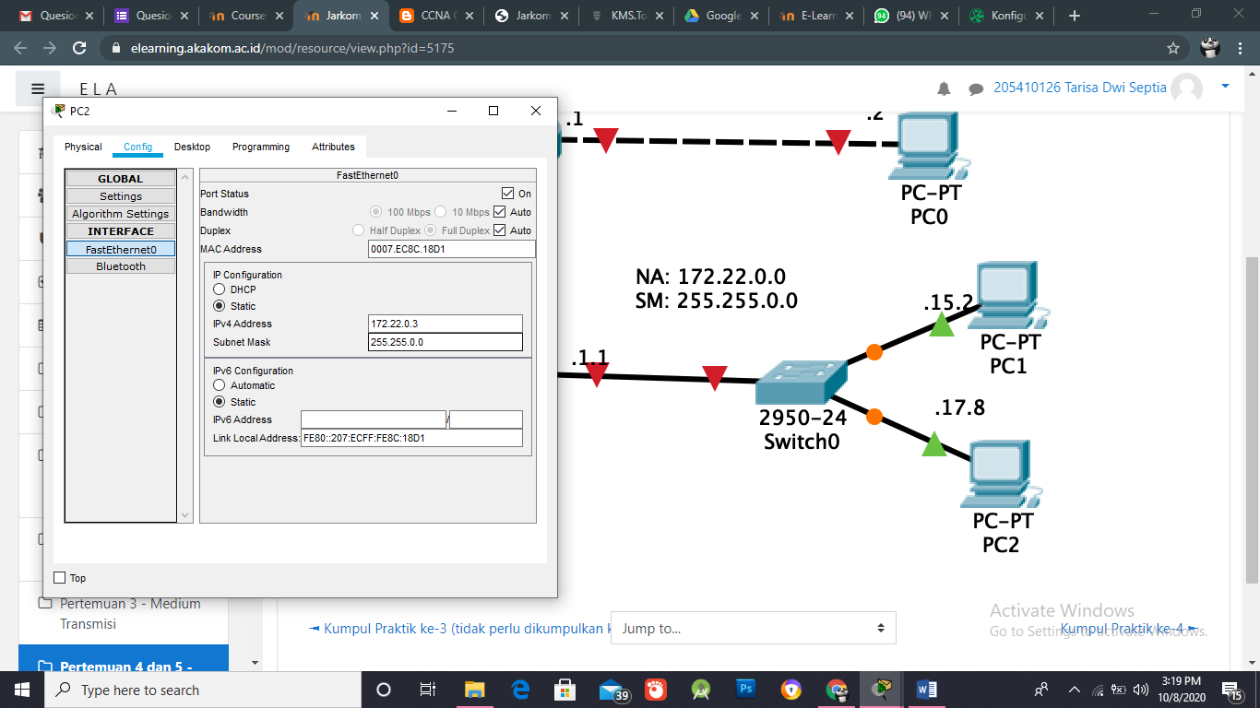

1. 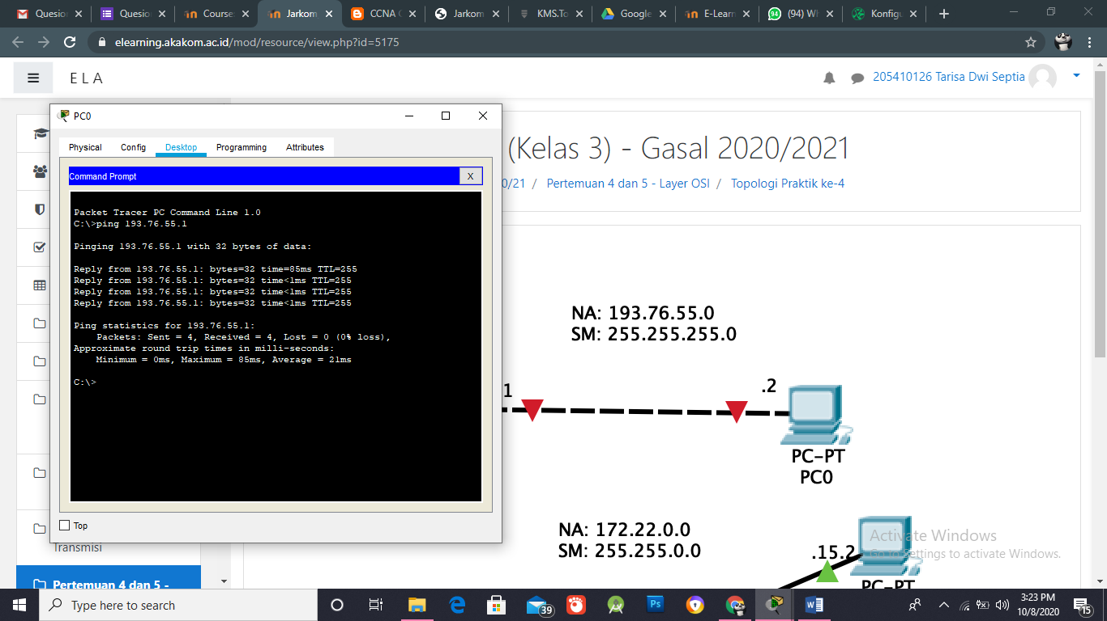Hasil ping PC0 -> Router
2. Hasil ping PC 1 – router

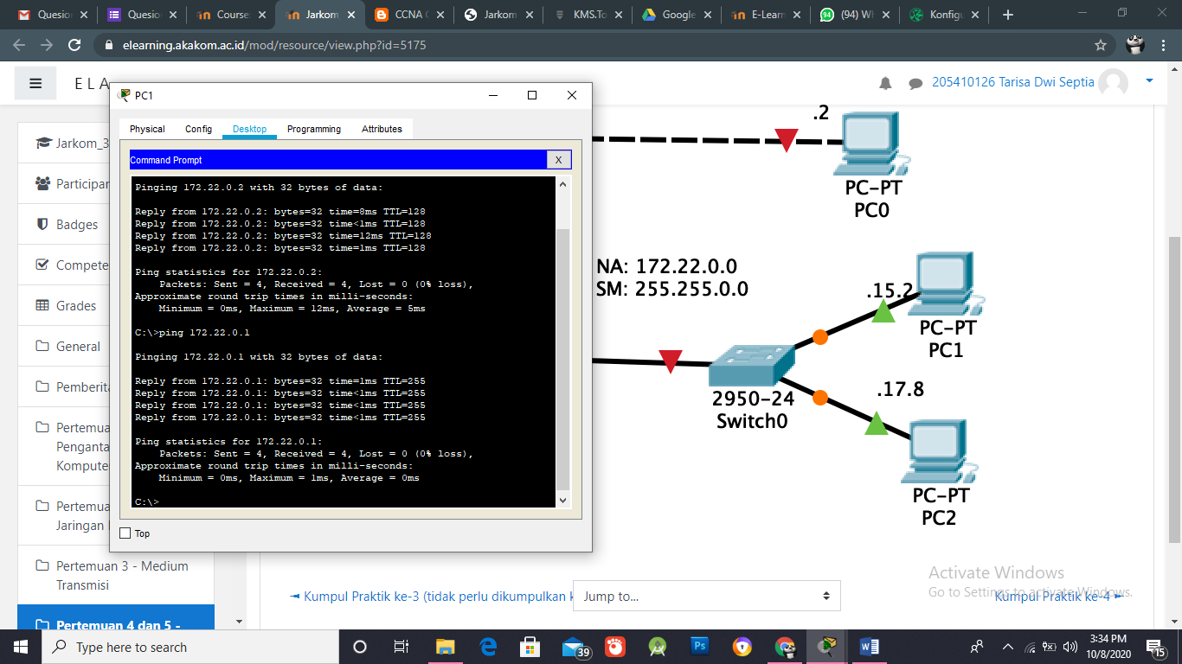

1. 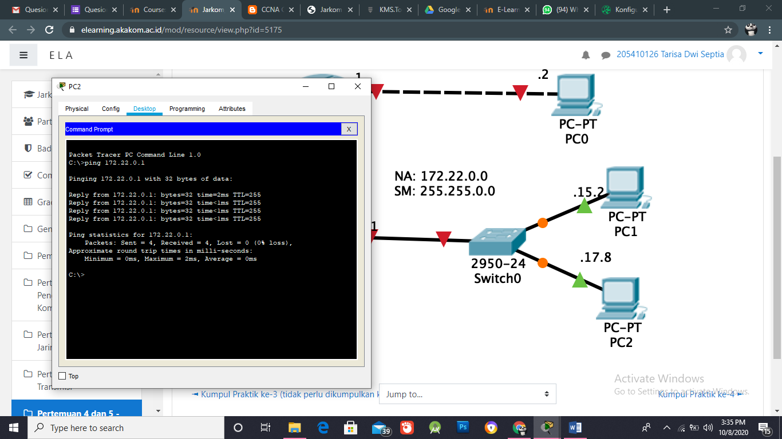Hasil ping PC 2 – Router
2. Topologinya

